Exp.No-13
13. Perform Perspective Transformation on the Video.

Aim:
To perform perspective transformation on a video using OpenCV.
Procedure:
- Start the program.
- Import the OpenCV and NumPy libraries.
- Open the input video.
- Read the video frame by frame.
- Define four source points.
- Define four destination points.
- Compute the perspective transformation matrix.
- Apply the perspective transformation to each frame.
- Display the original and transformed video.
- Press Q to stop the program.
- Release the video and close all windows.
- Stop the program.
Program:
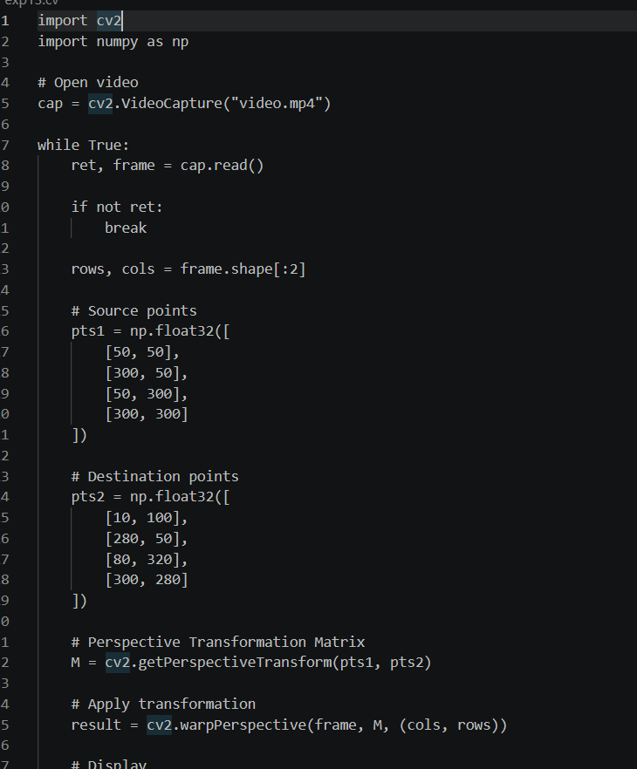

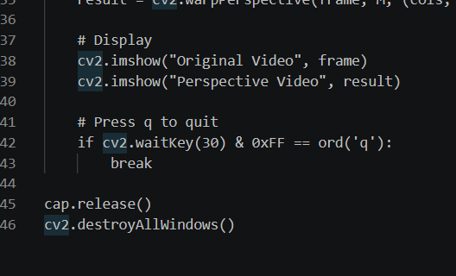

Output:
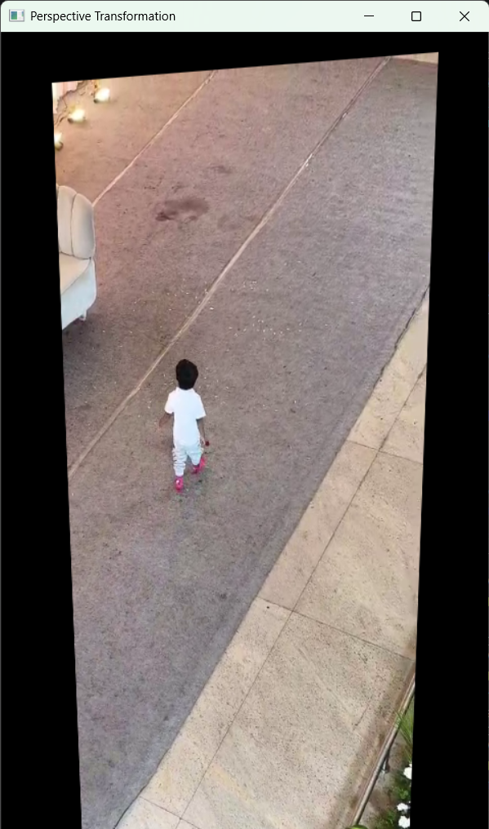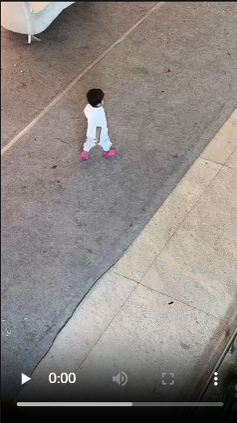

Result:
The perspective transformation was successfully applied to each frame of the input video, and the transformed video was displayed.

